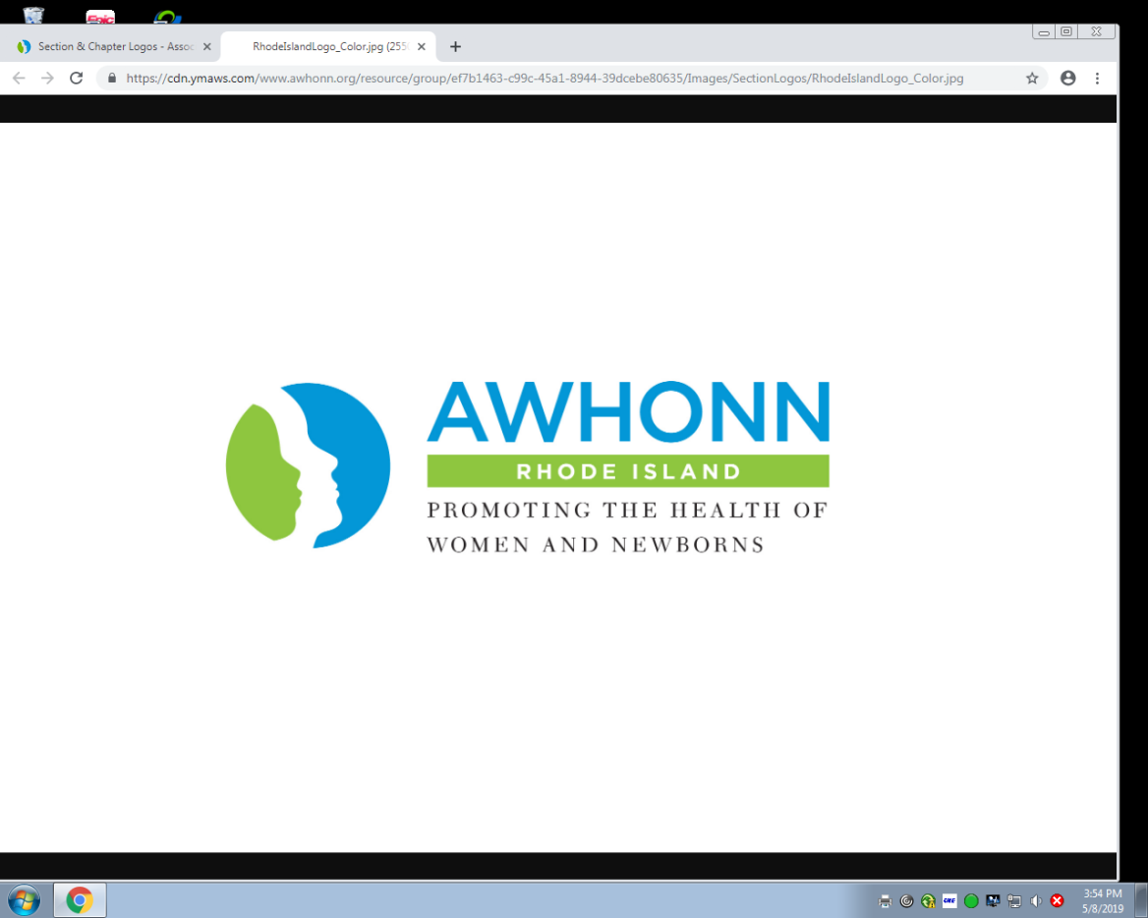

**2019 Perinatal Nursing Conference**

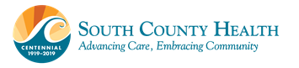

Come explore contemporary topics in maternal/newborn health. Topics include the nurse’s role in maternal mortality, updates on the Preventing Maternal Death Act, use of medicinal cannabis and cannabis in lactation, and AWHONN’s Post-Birth Warning Signs. Two patients will tell their stories – one a story of loss and one a story of survival.

Welcome / AWHONN RI Chapter Update Dale Monnier MS, RNC-OB, C-EFM, IBCLC

*We Can Change This: The Nurse’s Role in Maternal Mortality* Rose Horton MSM, RNC

*Margaret’s Memory* Sandy Clossick and Arthur Slader

*Preventing Maternal Death Act and Next Steps in Reducing Maternal Morbidity and Mortality* Seth Chace MA

*Supporting Patient Safe and Effective Use of Medicinal Cannabis* Carey Clark PhD, RN, AHN-BC, RYT

*Cannabis Use in (Pregnancy and) Lactation: High Time for a Review* Lauren Hanley MD, IBCLC

*AWHONN Post-Birth Warning Signs: Nurses’ Role in*

*Reducing Postpartum Maternal Morbidity and Mortality* Anne Santa-Donato MSN, RNC-OB

*Surviving A Placental Abruption: My Birth and Recovery Story* Jeanna Wilson

**Monday, October 7, 2019**

**7:30 AM – 4:15 PM**

**Women & Infants Hospital**

101 Dudley Street

Providence, RI 02905

Continental Breakfast & Lunch Provided

Register on eventbrite @ <https://www.eventbrite.com/e/awhonn-ri-2019-annual-conference-tickets-64799920306?aff=ebdssbdestsearch>

**Join in our *Healthy Mom & Baby Diaper Drive Challenge* by donating diapers at the conference**

AWHONN Member: $110

Non-Member: $140

CEs pending. Attendance at this conference will meet State of RI nursing license renewal requirements for substance abuse continuing education hours.